**Final Year B. Tech., Sem VII 2022-23**

**Cryptography And Network Security**

**PRN/ Roll No: 2020BTECS00206**

**Full Name: SAYALI YOGESH DESAI**

**Batch: B4**

**Assignment No. 5**

**COLUMNAR TRANSPOSITION CIPHER**

1. **Aim:**

Encrypt the given plain text using Columnar Transposition Algorithm.

1. **Theory:**

Columnar Cipher Encryption Algorithm:

In a transposition cipher, the order of the alphabets is re-arranged to obtain the cipher-text. 1. The message is written out in rows of a fixed length, and then read out again column by column, and the columns are chosen in some scrambled order.

2. Width of the rows and the permutation of the columns are usually defined by a keyword. 3. For example, the word HACK is of length 4 (so the rows are of length 4), and the permutation is defined by the alphabetical order of the letters in the keyword. In this case, the order would be “3 1 2 4”.

4. Any spare spaces are filled with nulls or left blank or placed by a character

(Example: _).

5. Finally, the message is read off in columns, in the order specified by the keyword

1. **Code:**

#include<bits/stdc++.h>

using namespace std;

int main()

{

string s;

cout << "Enter plain text" << endl;

getline(cin, s);

string x;

for (int i = 0; i < s.length(); i++)

if (s[i] != ' ')

x += s[i];

s = x;

int kSize;

cout << "Enter key size" << endl;

cin >> kSize;

vector<int> k(kSize);

int n = s.size();

for (int i = 0; i < kSize; i++)

cin >> k[i];

cout << "\nPlain text is: " << s << endl;

vector<vector<char>> mat(kSize + 1);

int row = 0;

for (int i = 0; i < s.length(); i++)

{

mat[k[row++]].push_back(s[i]);

row = row % kSize;

}

string cipher = "";

for (int i = 0; i <= kSize; i++)

for (int j = 0; j < mat[i].size(); j++)

cipher += mat[i][j];

cout << "\nCipher text is: " << cipher;

return 0;

}

1. **Output:**

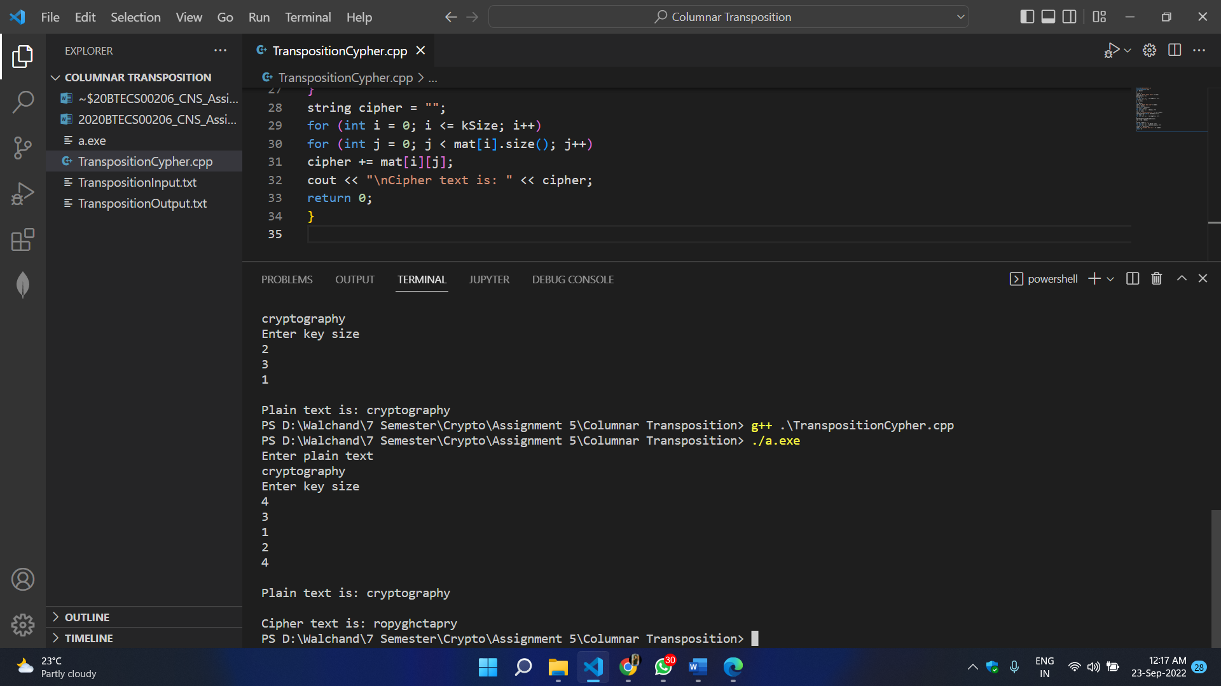

1. **Conclusion:**

Successfully encrypted the given plain text using Columnar Transposition Technique.

**RAIL FENCE TRANSPOSITION**

1. **Aim:**

Given the plain text, encrypt it using Rail Fence Encryption Algorithm.

1. **Theory:**

Rail fence Cipher Encryption Algorithm:

* In the rail fence cipher, the plain-text is written downwards and diagonally on successive rails of an imaginary fence.
* When we reach the bottom rail, we traverse upwards moving diagonally, after reaching the top rail, the direction is changed again. Thus, the alphabets of the message are written in a zig-zag manner.
* After each alphabet has been written, the individual rows are combined to obtain the cipher-text.

1. **Code:**

#include<bits/stdc++.h>

using namespace std;

int main()

{

string s;

cout << "Enter plain text" << endl;

getline(cin, s);

string x;

for (int i = 0; i < s.length(); i++)

if (s[i] != ' ')

x += s[i];

s = x;

int k;

cout << "Enter key" << endl;

cin >> k;

cout << "\nPlain text is: " << s << endl;

cout << "Key is: " << k << endl;

int n = s.length();

vector<vector<char>> mat(k);

int row = 0;

int flg = 1;

for (int i = 0; i < s.length(); i++)

{

mat[row].push_back(s[i]);

row += flg;

if (row == (k - 1))

{

flg = -1;

}

if (row == 0)

flg = 1;

}

string cip = "";

for (int i = 0; i < k; i++)

{

for (int j = 0; j < mat[i].size(); j++)

cip += mat[i][j];

}

s = cip;

transform(cip.begin(), cip.end(), cip.begin(), ::toupper);

cout << "\nCipher text is: " << cip;

int tp = 1;

vector<vector<int>> matd(k);

row = 0;

flg = 1;

for (int i = 1; i <= n; i++)

{

matd[row].push_back(i);

row += flg;

if (row == (k - 1))

{

flg = -1;

}

if (row == 0)

flg = 1;

}

vector<int> dd;

for (int i = 0; i < k; i++)

{

for (int j = 0; j < mat[i].size(); j++)

dd.push_back(matd[i][j]);

}

cout << endl;

map<int, char> m;

for (int i = 0; i < n; i++)

m[dd[i]] = s[i];

string plain = "";

for (int i = 1; i <= n; i++)

plain += m[i];

cout << "\n\nPlain text after decription is: " << plain;

}

1. **Output:**

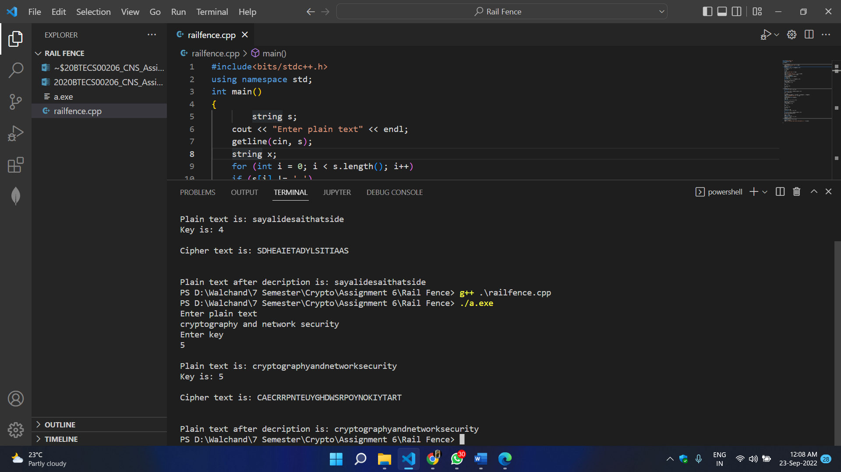

1. **Conclusion:**

Successfully encrypted plain text using rail fence cipher.